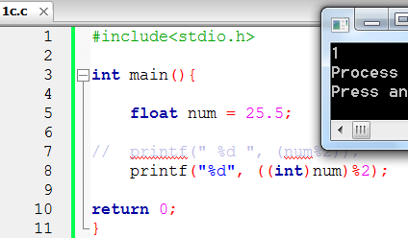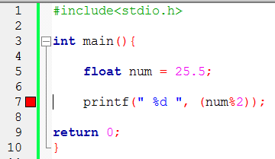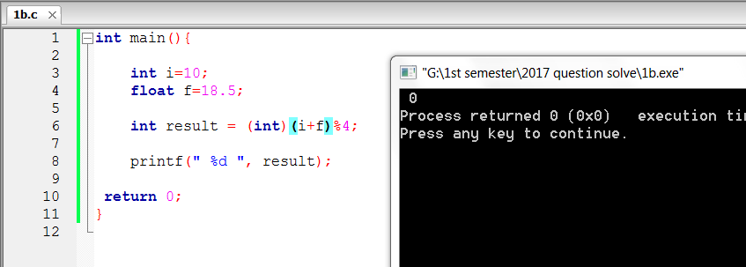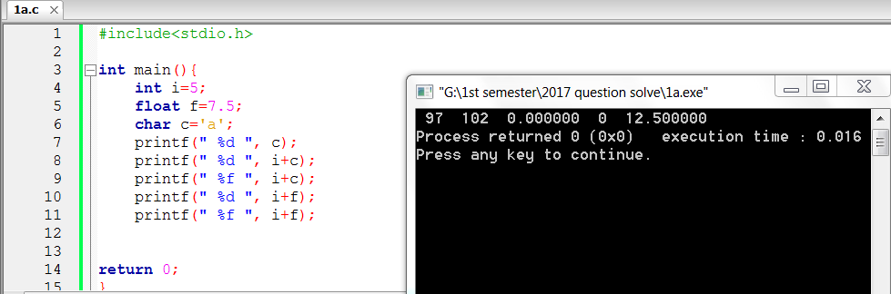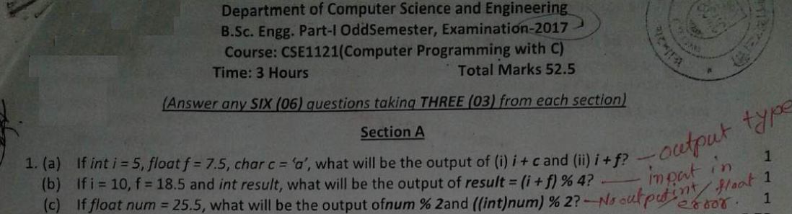

**1c**

25.5%2 not possible because 25.5 is a floating point number.

(Int) 25%2 12*2=24 25-24 =1

Type def

No output possible

b) No output possible. Because int and float cannot be added.

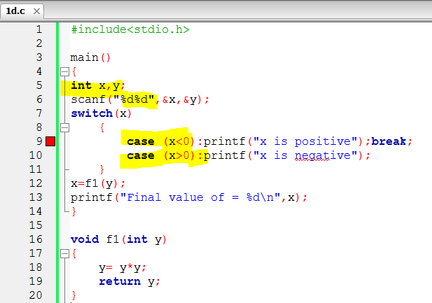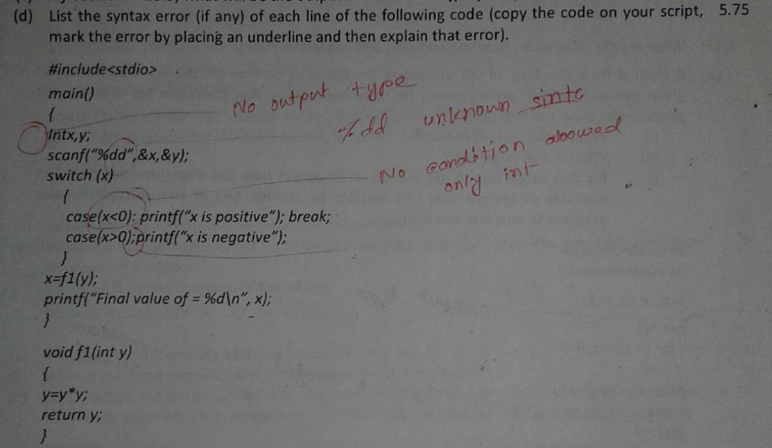

Here case have condition but we must use constant values for cases

**2 a) Answer:** The name of array contains the address or location of the array in the memory. When we declare an array, we set the name of the array and set the index value up to n. Here, we set n number of memory space of the same data type in the corresponding location in the memory.

 We use the array name as a pointer to store elements into the array. After that, we print the elements of the array using the same pointer.

An array name is a pointer (address), so we just pass an array name to a function which means to pass a pointer to the array.

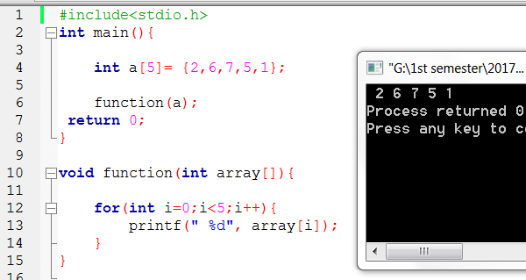

int main(){

int a[5]= {2,6,7,5,1};

function(a);

return 0;

}

void function(int array[]){

for(int i=0;i<5;i++){

printf(" %d", array[i]);

}

}

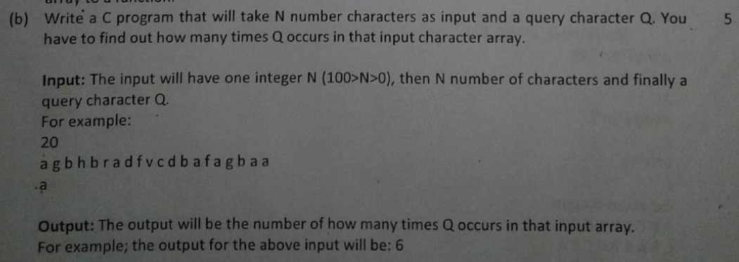

#include<stdio.h>

#define N 100

int main(){

int n,freq=0;

char queue[N], search;

printf("Enter one integer N (100>N>0): ");

scanf("%d",&n);

fflush(stdin);

for(int i=0;i<n;i++){

scanf("%c",&queue[i]);

}

fflush(stdin);

printf("Enter a character to find its frequency: ");

scanf("%c", &search);

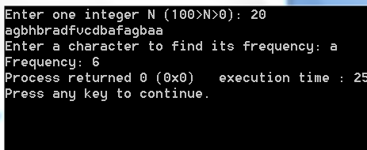

for(int i=0;i<n;i++){

if(search == queue[i]){

freq++;

}

}

printf("Frequency: %d", freq);

return 0;

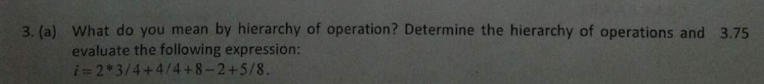}

**3 a) Answer**: The priority in which the operations in an arithmetic statement are performed is called the hierarchy of operations. Operator precedence determines the grouping of terms in an expression and decides how an expression is evaluated. Certain operators have higher precedence than others.

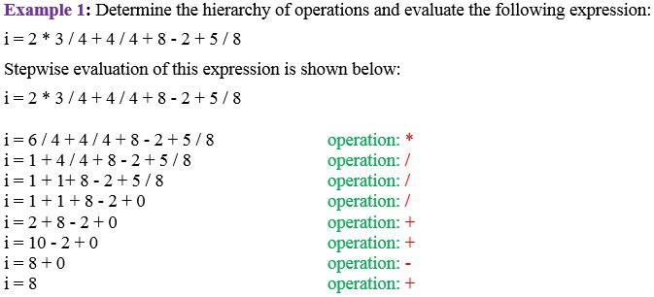Given,

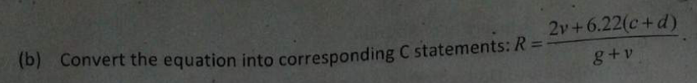

**3 b) Answer:**

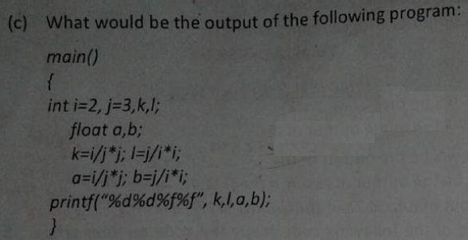int R = ((2*v)+(6.22*(c+d)))/(g+v);

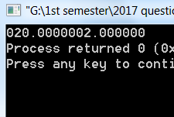

Output:

020.0000002.000000

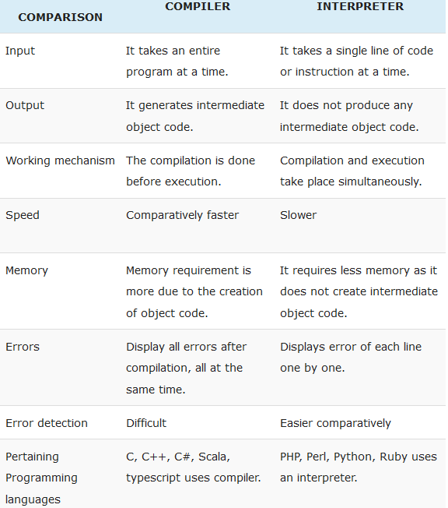

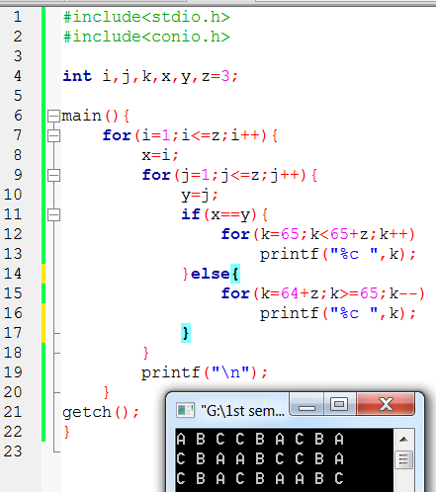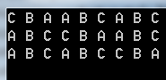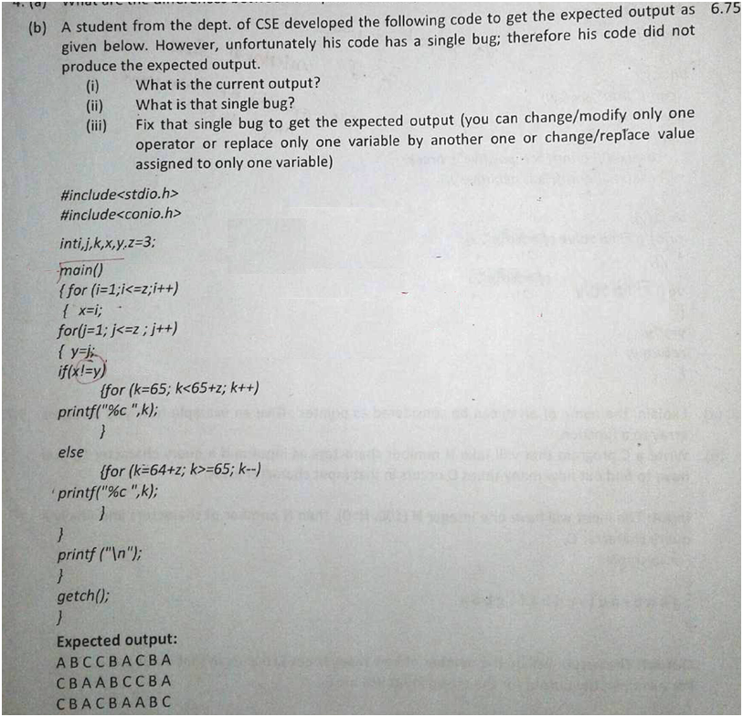

ii) Solution: Single bug is in the if condition of the 2nd loop.

i) Solution: Current output

iii) Solution: Replace x!=y by x==y

Query: 18115@imperial.edu.bd